# Weekly Report – 07.11.2017

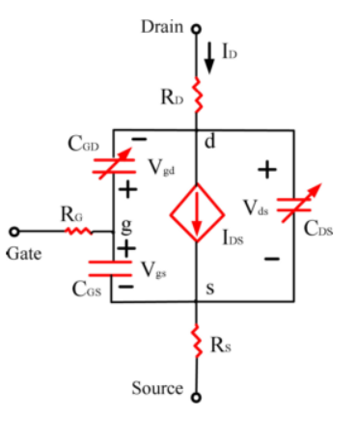

Figure 1: The circuit in GaNFET

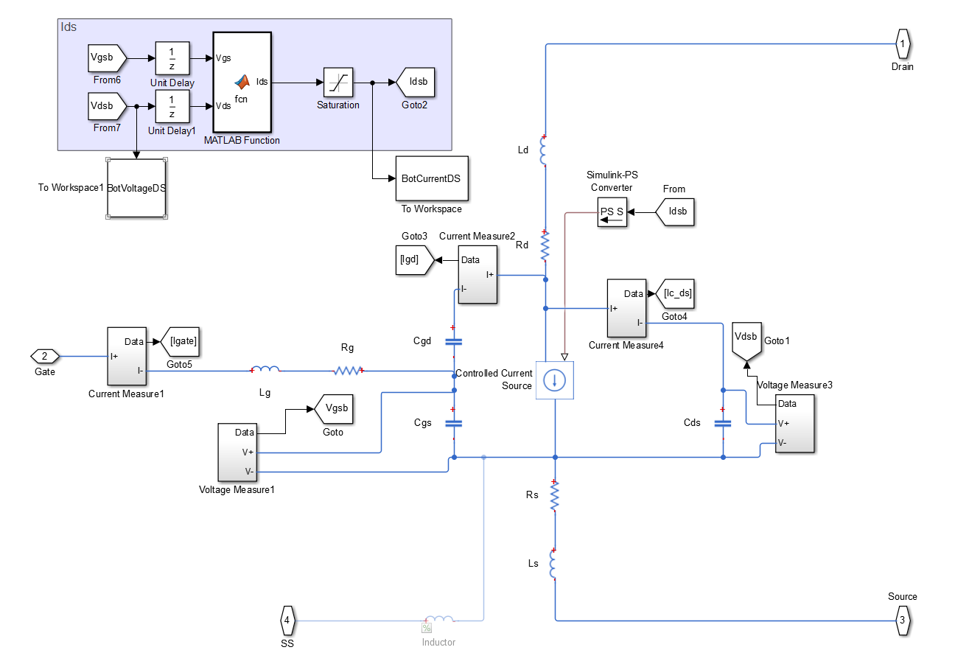

Figure 2: GaN Model

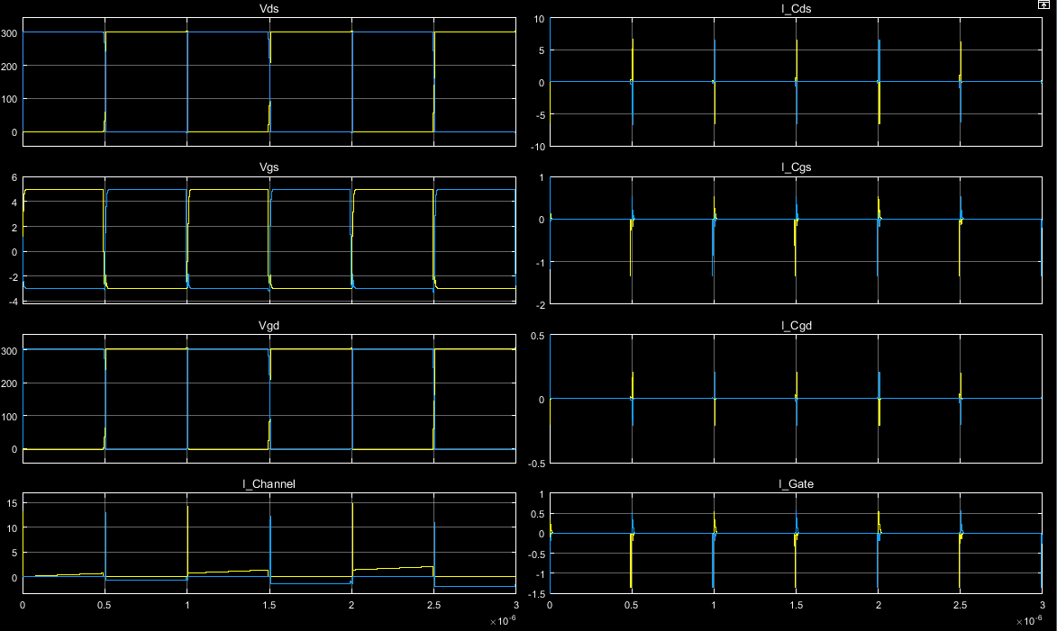

Figure 3: Top and Bottom Switch Characteristics (Yellow-> TOP, Blue-> BOTTOM)

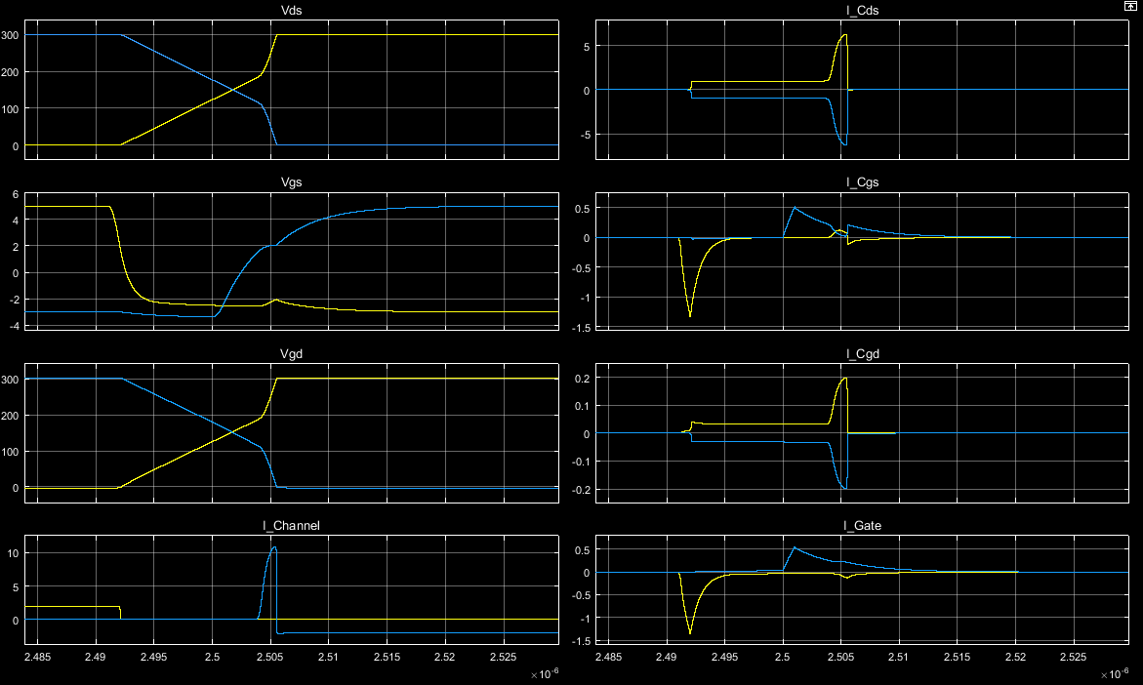

Figure 4: Top Switch Turn OFF, Bottom Switch Turn ON

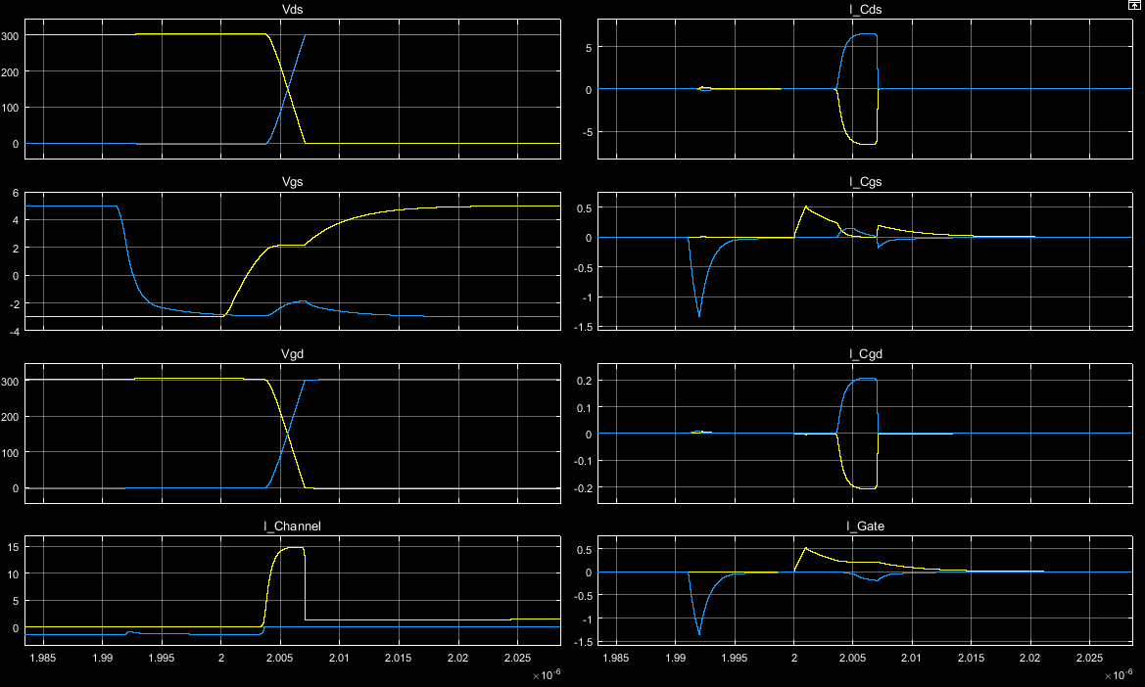

Figure 5: Top Switch Turn ON, Bottom Switch Turn OFF

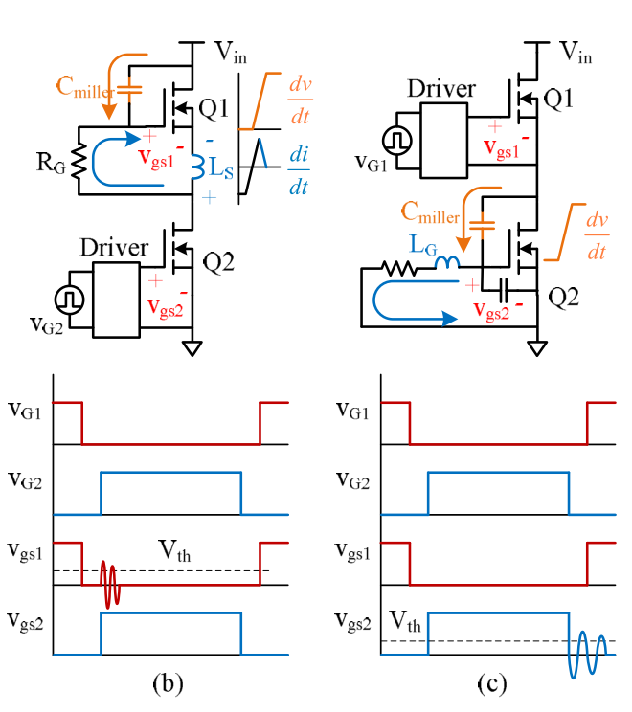

Figure 6: Reasons for Oscillation

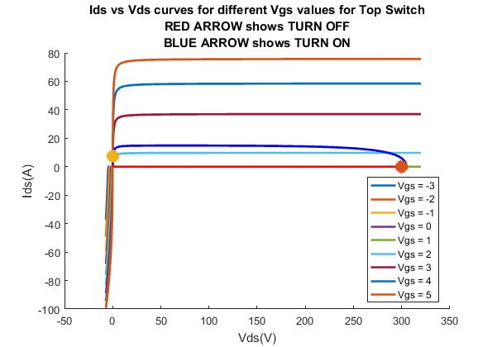

Figure 7: Top Switch Turn ON/OFF Curves

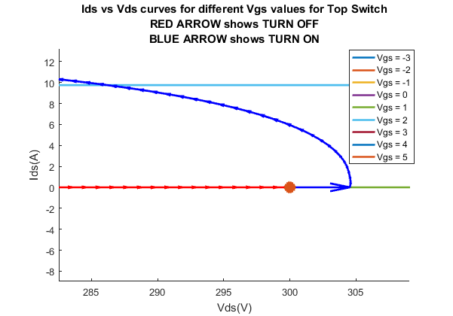

Figure 8: Top Switch Turn ON/OFF

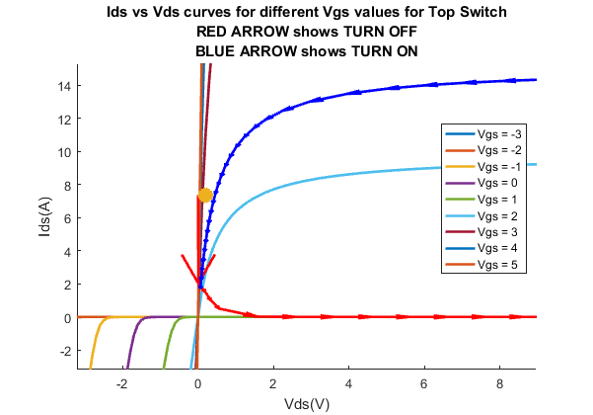

Figure 9: Top Switch Turn ON / OFF

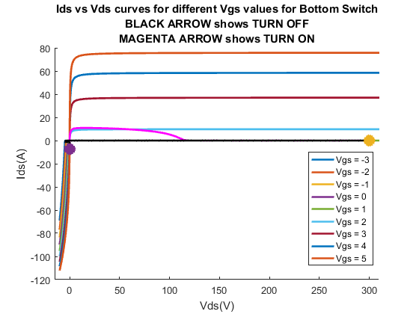

Figure 10: Bottom Switch Turn ON/OFF Curves

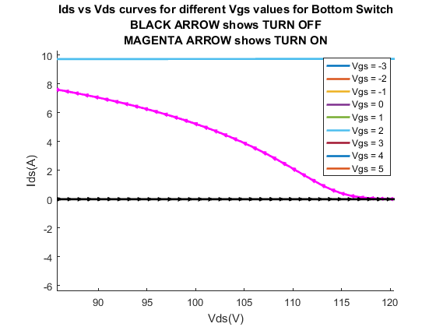

Figure 11: Bottom Switch Turn ON/OFF

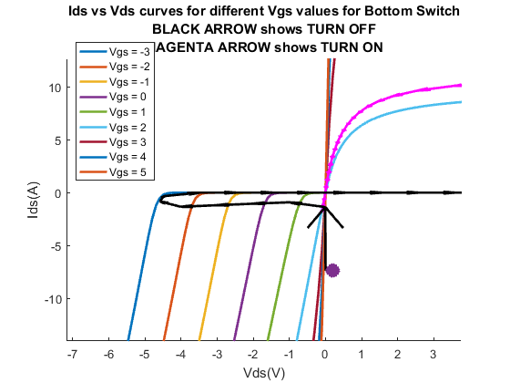

Figure 12: Bottom Switch Turn ON/OFF

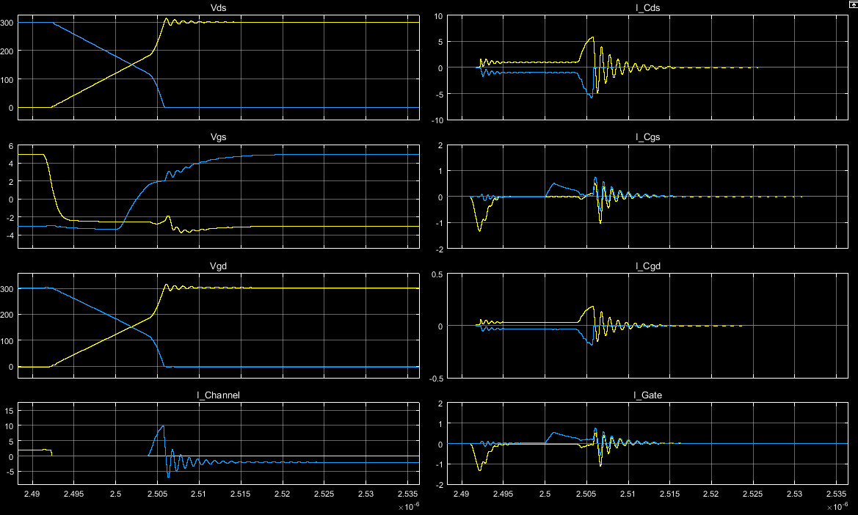

Figure 13: Top Switch Turn OFF, Bottom Switch Turn ON when Ls and Lg are connected

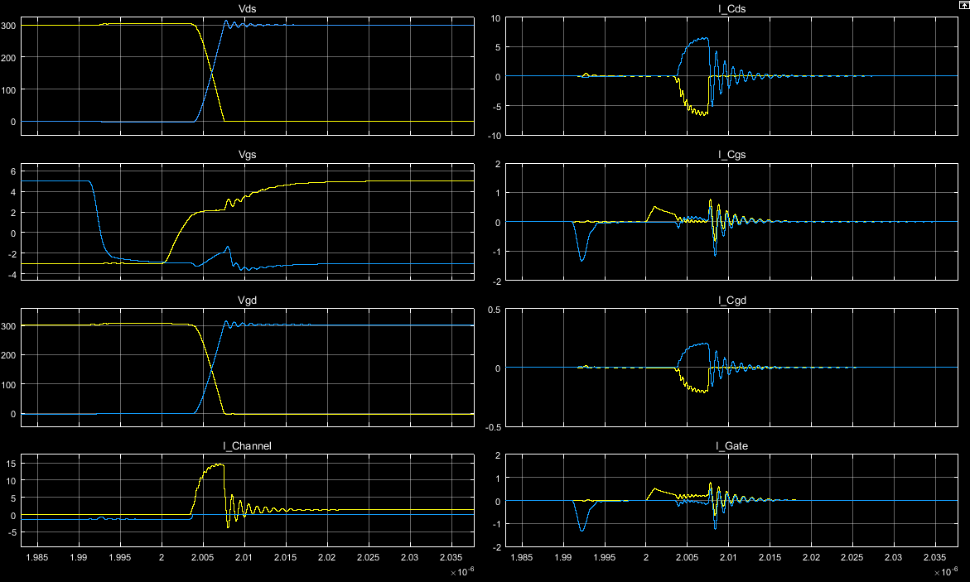

Figure 14: Top Switch Turn ON, Bottom Switch Turn ON when Ls and Lg are connected

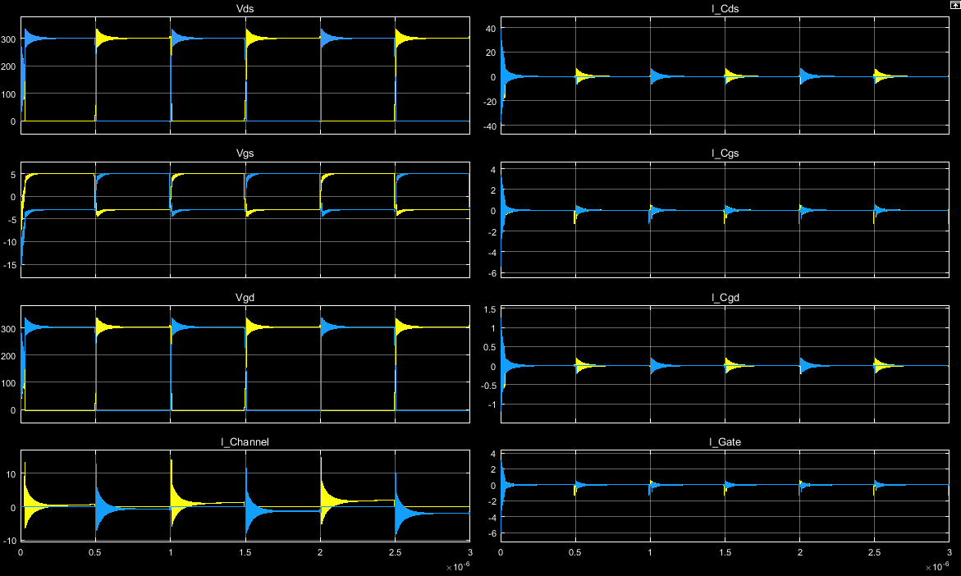

Figure 15: Switch Characteristics when Ld is connected too

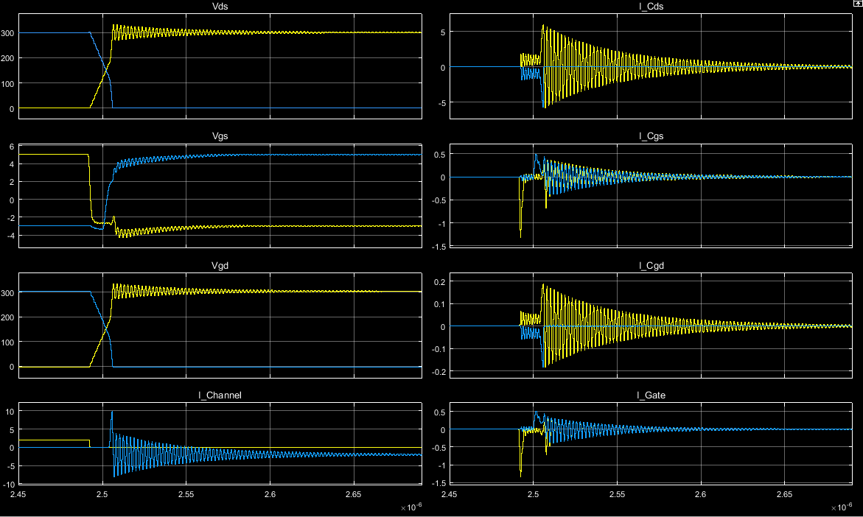

Figure 16: Top Switch Turn OFF, Bottom Switch Turn ON when all parasitic exist

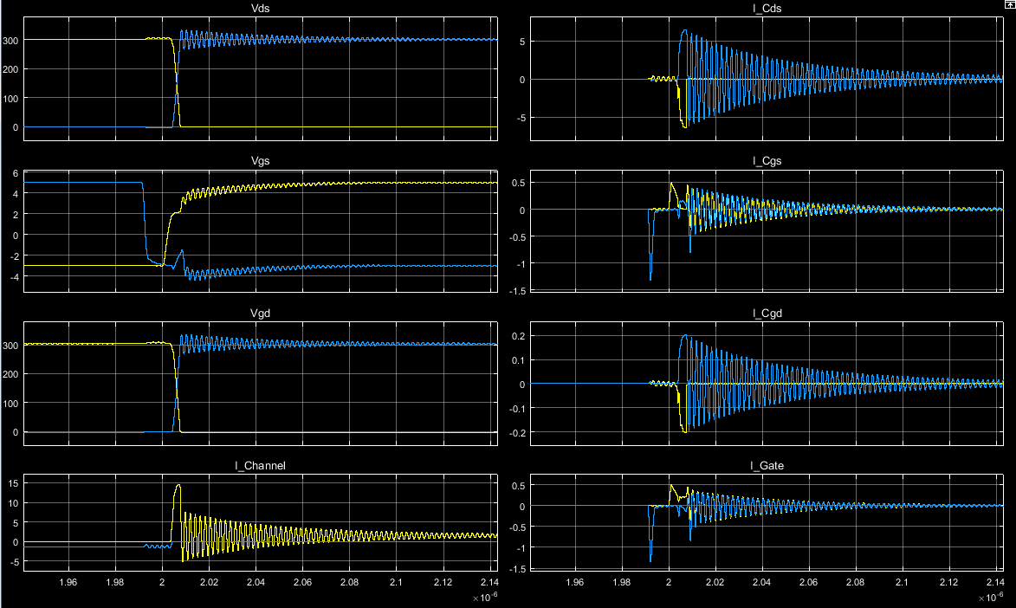

Figure 17: Top Switch Turn ON, Bottom Switch Turn OFF when all parasitic exist

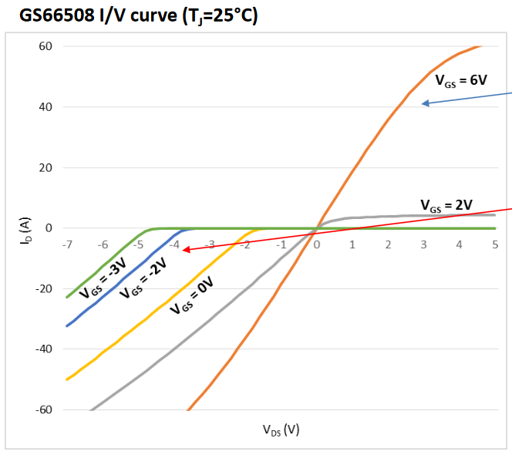

Figure 18: I-V Curve for GaNFET

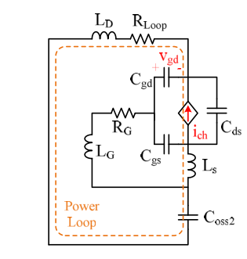

Figure 19: Small Signal Equivalent Circuit for Reverse Conduction

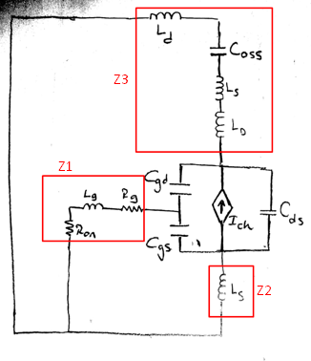

Figure 20: Our Small Signal Circuit for Reverse Conduction

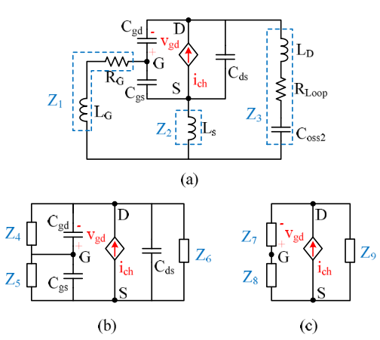

Figure 21: Simplification

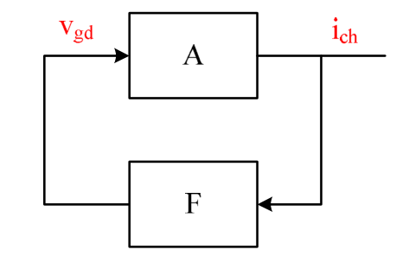

Figure 22: Block Diagram for Reverse Conduction

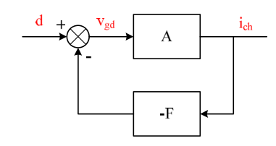

Figure 23: Proper Block Diagram for Reverse Conduction



Figure 24: I-V Curve for GaNFET

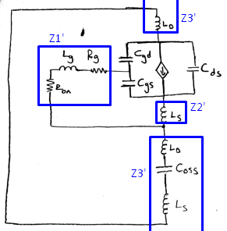

Figure 25: Small Signal Circuit for Forward Conduction

Same characteristic equations for open loop transfer functions!



Figure 26: Pole Zero Map for Closed Loop Transfer Function



Figure 27: Pole Zero Map - Zoomed

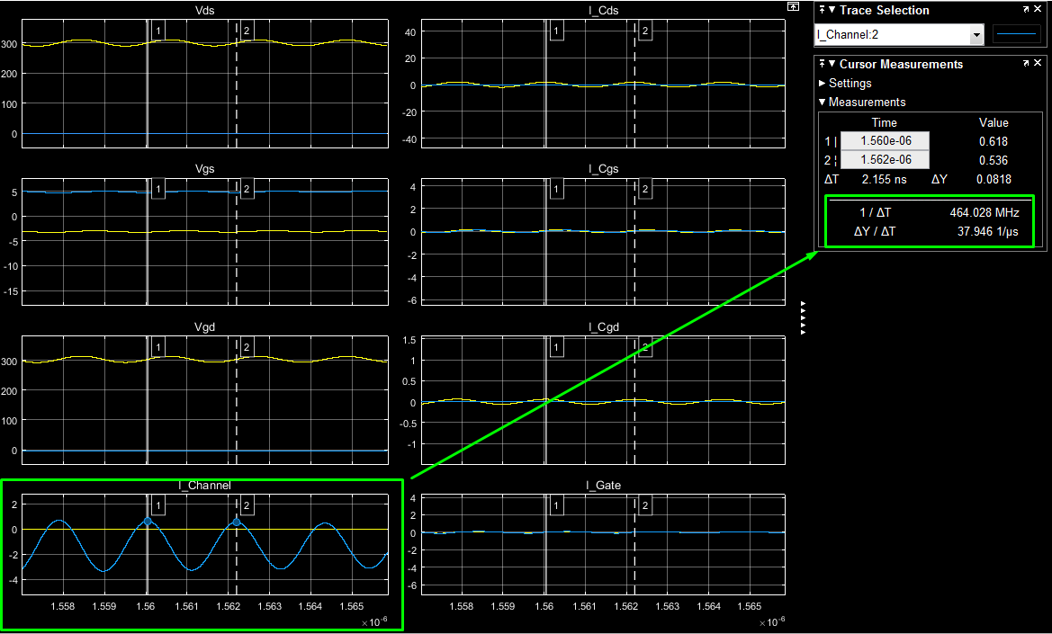

Figure 28: Reverse Conduction Oscillation

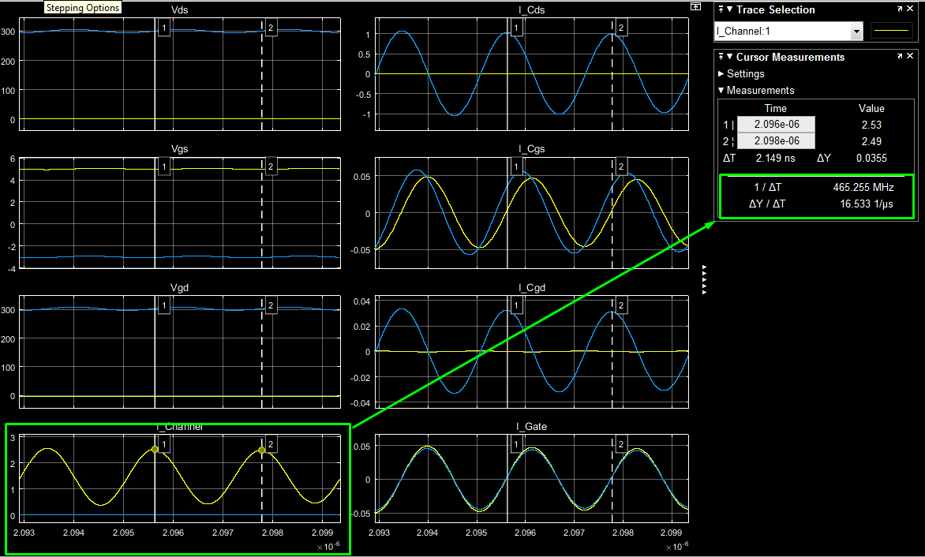

Figure 29: Forward Conduction Oscillation

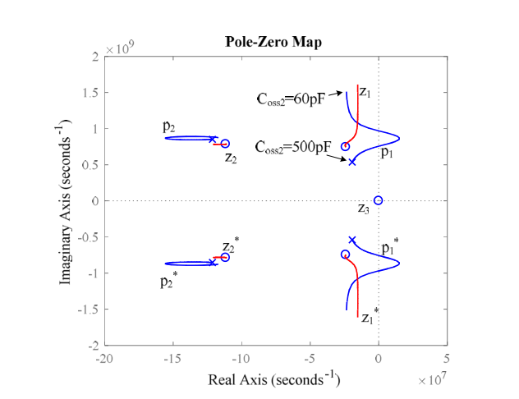

Figure 30: Root-Locus

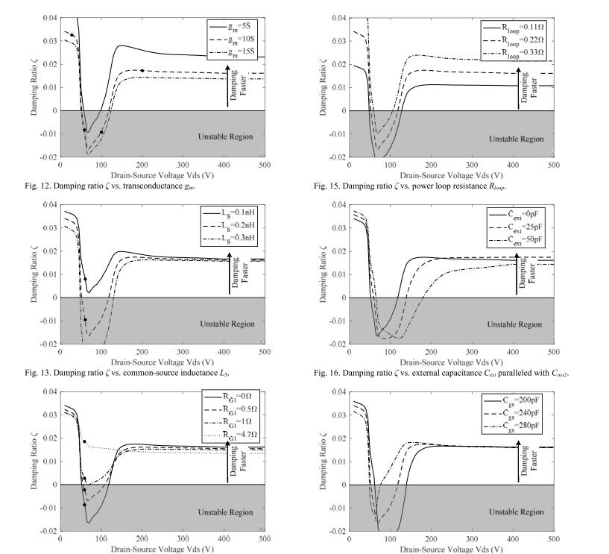

Figure : Damping Control

Next Week

* Capacitance Modelling

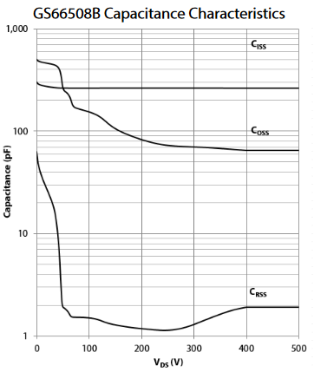

Figure 32: Ciss, Coss, Crss vs Vds Graph

* Loss Analyzation
* Stability Analyzation